Project Initialization and Planning Phase

Date | 20 September
Team ID | MCA
Project Name | Smartphone Usage and Digital Addiction & Well-being Analytics
Maximum Marks | 3 Marks

Define Problem Statements (Customer Problem Statement Template):
Create problem statements to understand the challenges faced by smartphone users related to excessive smartphone usage, digital addiction, and overall well-being. The Customer Problem Statement template helps identify how smartphone usage patterns may affect users' sleep, productivity, social activities, and daily routines. A well-defined problem statement helps the project team understand users' concerns and analyze smartphone usage data to identify patterns of digital addiction and their relationship with well-being. This understanding can help in developing meaningful i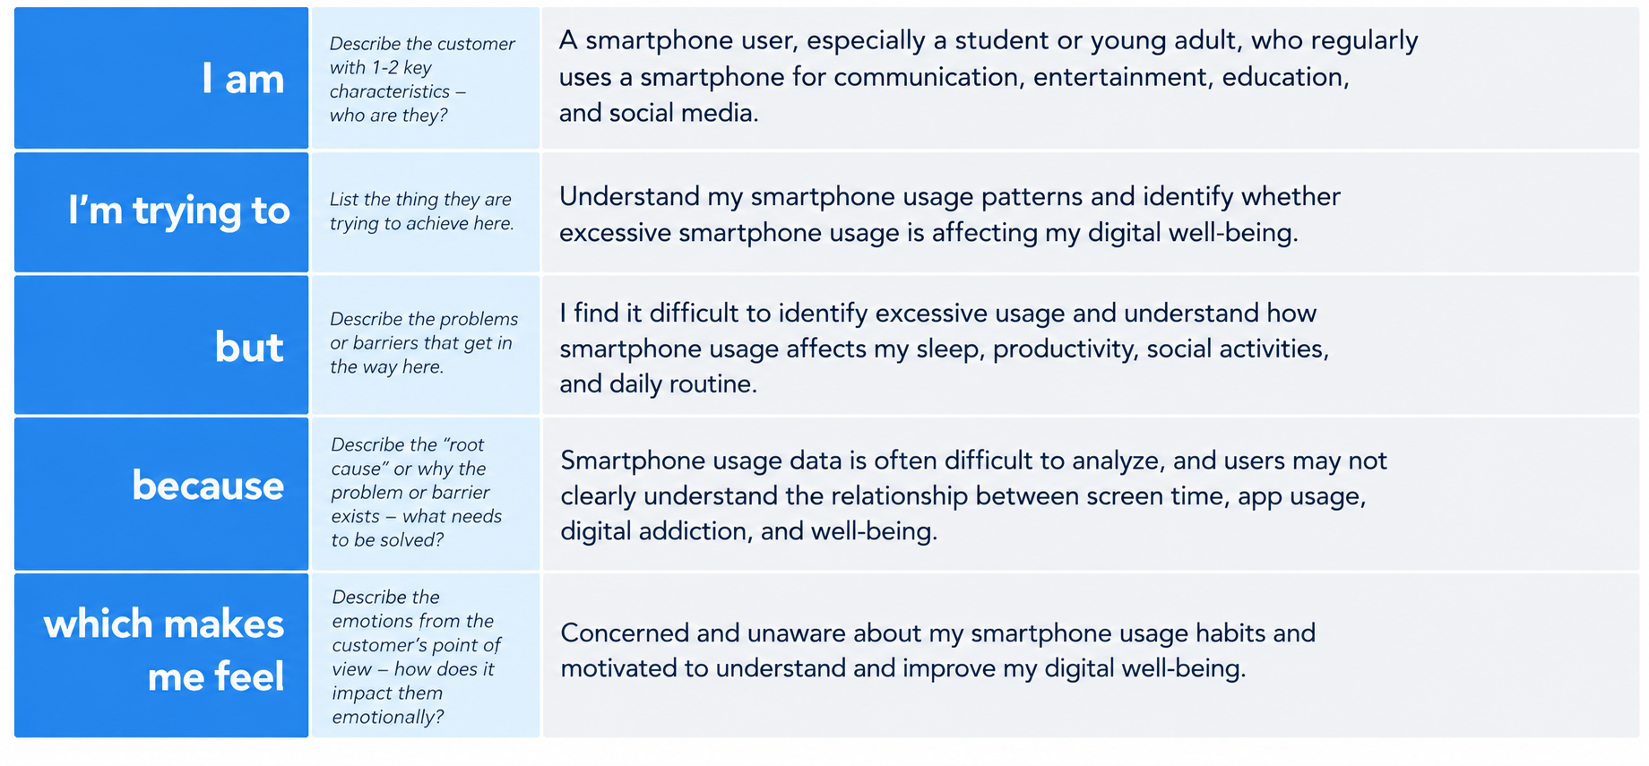nsights and supporting healthier digital habits.

Reference: https://miro.com/templates/customer-problem-statement/
Example:


Problem  Statement (PS) | I am  (Customer) | I’m trying to | But | Because | Which makes me feel
PS-1 | A smartphone user | Understand my smartphone usage and screen-time | I cannot easily identify excessive smartphone usage | Smartphone usage data is difficult to understand and analyze | Concerned about my smartphone usage
PS-2 | A student or young adult | Maintain a healthy balance between smartphone usage and daily life | Excessive smartphone use may affect my sleep, productivity, and daily activities |  | Worried about digital addiction and motivated to improve my digital well-being
  I do not have clear insights into the relationship between smartphone usage and well-being

